**Assignment- 1**

|  |  |
| --- | --- |
| Student name | Thamizhendhi.E |
| Roll no/Reg no | 411419104032 |
| College Name | New Prince Shri Bhavani Clg Of Engg & Tech |
| Mark | 02 |

**Basic Python**

## Split this string

**Solution:**

s **=** "Hi there Sam!"

print(s**.**split())

**Output:**

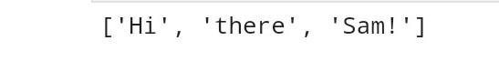

## 2. Use .format() to print the following string.

### Output should be: The diameter of Earth is 12742 kilometers.

**Solution :**

x**=** "Earth"

y**=** 12742

print('The diameter of the {} is {} kilometers'**.**format(x,y))

**Output:**

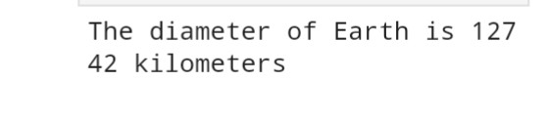

## 3.In this nest dictionary grab the word "hello"

## Solution :

d={'k1':[1,2,3,{'tricky':['oh','man','inception',{'target':[1,2,3,'hell]}]}

c**=**d['k1'][3]

e**=**c['tricky'][3]

f**=**e['target'][3]

print(f)

**Output:**



# Numpy

**import** numpy **as** np

## 4.1 Create an array of 10 zeros?

## 4.2 Create an array of 10 fives?

**Solution:**

a**=**np**.**zeros(10)

a

**Output:**

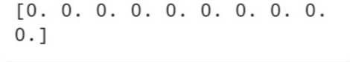

**Solution:**

c**=**a**+**5

c

**Output:**

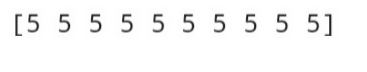

## 5. Create an array of all the even integers from 20 to 35

**Solution:**

np**.**arange(20,35,2)

**Output:**

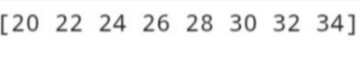

## 6. Create a 3x3 matrix with values ranging from 0 to 8

**Solution:**

a**=**np**.**arange(0,9)

a**.**reshape(3,3)

**Output:**

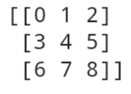

## 7. Concatenate a and b

## a = np.array([1, 2, 3]), b = np.array([4, 5, 6])

**Solution:**

a **=** np**.**array([1, 2, 3])

b **=** np**.**array([4, 5, 6])

np**.**concatenate((a,b),axis**=**0)

**output:**



# Pandas

## 8. Create a dataframe with 3 rows and 2 columns

**Solution:**

**import** pandas **as** pd

d**=**{"Name":["Vasanth","Shyam","Dhana"],"Age":[20,25,23]}

df**=**pd**.**DataFrame(d)

df

**Output:**

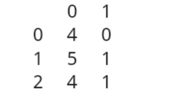

## 9. Generate the series of dates from 1st Jan, 2023 to 10th Feb, 2023

**Solution:**

p **=** pd**.**date_range(start**=**'1-1-2023',end**=**'10-2-2023')

**for** val **in** p:

print(val);

**Output:**

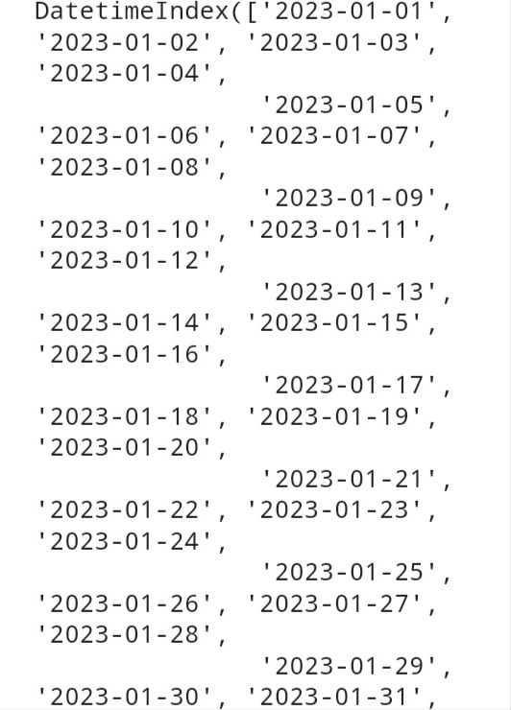

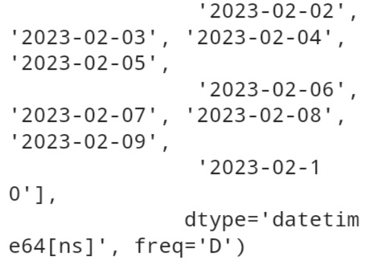

## 10. Create 2D list to DataFrame

lists = [[1, 'aaa', 22], [2, 'bbb', 25], [3, 'ccc', 24]]

**Solution:**

lists **=** [[1, 'aaa', 22], [2, 'bbb', 25], [3, 'ccc', 24]]

dff**=**pd**.**DataFrame(lists)

dff

**Output:**

